Comprehensive Project Proposal for The Nigeria Prize for Science and Innovation 2026 NLNG Nigeria Prizes – www.thenigeriaprizes.org

Category: The Nigeria Prize for Science (Innovation in Digital Infrastructure, AI, and Socio-Economic Transformation)

Prize Value: USD 100,000
Project Name: FEMZYK NAARA PLATFORM

Project Tagline: The Trust Layer for Africa’s Informal Economy and Digital Society

Date: April 2026
Submitted by:
Name: Keripe Olufemi Benua,
Phone: +2349021156310, +2349161839343
Email: femzykenterprisesltd@gmail.com
Post: Founder and Lead AI-Powered Developer

Executive Summary (Part 1 – Executive Overview)
Nigeria’s informal economy contributes an estimated 58–65% to GDP and employs over 80–93% of the workforce, with informal jobs accounting for approximately 92% of total employment. This sector is the primary engine of livelihood for tens of millions, including 30–50 million apprentices and artisans engaged in traditional trades such as auto mechanics, tailoring, welding, carpentry, and phone repair. Traditional apprenticeship systems have historically driven skill transfer and entrepreneurship across the country, yet they face persistent challenges: lack of standardized certification, absence of verifiable credentials, potential exploitation, limited legal protections, and poor integration with formal opportunities, finance, or digital tools.
Compounding these issues are fragmented gig opportunities, idle community resources, weak civic engagement mechanisms, market information asymmetry, and escalating cyber threats. Nigeria has recorded thousands of cyber attacks weekly, with phishing, business email compromise, and related frauds causing substantial losses (digital payment fraud alone reached ₦52.26 billion in 2024 before declining to ₦25.85 billion in 2025). These structural gaps render human capital invisible to employers, banks, governments, and NGOs, limiting productivity, financial inclusion, and evidence-based policymaking.
FEMZYK NAARA PLATFORM is a modular, offline-first, AI-enhanced digital public infrastructure that digitizes, verifies, and interconnects these invisible systems. Powered by the unified Nàárà Core Engine, it transforms informal skills, learning, economic activities, civic participation, community resources, and user safety into verifiable, economically valuable, and policy-actionable data.
Scientific and Technological Innovation: The platform introduces a novel skill-graph engine, triangulated multi-source verification algorithms, dynamic AI-driven trust scoring (incorporating behavioral analysis and safety penalties), real-time Digital Safety Engine for proactive cyber threat detection, and robust offline synchronization mechanisms. These are delivered through Progressive Web App (PWA) technology, service workers, IndexedDB, and USSD/SMS fallbacks — directly addressing Nigeria’s digital divide, where data costs and connectivity remain significant barriers.
Vision: To create inclusive digital infrastructure that makes Nigeria’s (and Africa’s) informal economy visible, verifiable, and economically productive, while generating high-quality analytics for governments, NGOs, financial institutions, and national development planning.
Mission:
- Digitize apprenticeship and informal learning systems, providing verifiable proof-of-competency.
- Connect verified skills and activity records to local and global economic opportunities.
- Enable community-driven civic engagement through structured, measurable petitions.
- Facilitate equitable resource redistribution and economic transparency.
- Provide a modern, secure forum for discussion and collaboration.
- Deploy a single, consent-based identity system integrating all functions.
- Build analytics-ready data infrastructure while embedding proactive trust and safety intelligence.
Core Problem Solved: The invisibility and fragmentation of informal systems lead to mistrust, missed opportunities, resource waste, limited civic influence, and heightened vulnerability to scams. FEMZYK NAARA offers a holistic structural solution through 16 interconnected modules powered by one Core Engine.

Target Users (with Estimated Reach):
- Apprentices / Artisans (30–50M across SSA, Nigeria focused but room for expansion): Proof of skills, gigs, trust verification.
- Freelancers / Gig Workers (10–20M): Portfolio, earnings tracking, international access.
- Students / Lifelong Learners (20–40M): Offline skill acquisition and micro-certifications.
- Community Members (50–100M potential): Petitions, FreeCycle, engagement.
- Masters / Trainers (5–10M): Progress tracking, reputation building.
- NGOs / Governments / Employers: Verified data for planning, hiring, and programs.

Strategic Positioning & Key Differentiators: FEMZYK NAARA is digital infrastructure for invisible systems — modular, trust-first, offline-ready, data-driven, and global-expansion capable. It is not a marketplace, fintech, or simple e-learning app. Differentiators include first-of-its-kind digitization of informal African trades, integrated civic and resource tools, and a proactive Digital Safety Engine.
Key Metrics / Impact Goals:
- Short-term (0–12 months): 5–10 trades onboarded, 500–2,000 verified apprentices, 1,000+ free courses, 10,000+ active forum users, 5,000+ FreeCycle transactions.
- Medium-term (1–3 years): 3–5M active users, 50–100 trades, international gigs live, measurable policy influence via petitions.
- Long-term (3–5+ years): Pan-African coverage, standardized informal skill credentials, trusted infrastructure supporting Nigeria’s youth employment, digital inclusion, and evidence-based governance goals.
MVP Strategy for Demonstration: Focus on SkillForge + ProofPortfolio, FreeCycle, PetitionHub, and the Digital Safety Engine. A ~4–5 minute demo showcases an apprentice completing a verified skill, posting/claiming a resource, creating a petition with live signatures, and experiencing real-time safety protections.

Professional “Wow Factor”: Systemic modular ecosystem; novel AI for trust and safety in low-resource settings; proprietary data moat from ground-level activity logs; multi-impact across education, employment, civic participation, and digital safety — strongly aligned with national priorities.

Part 2 – Modules Breakdown (16 Interconnected Modules)
All modules operate through the single Nàárà identity and Nàárà Core Engine, ensuring seamless activity logging, trust propagation, analytics aggregation, and safety checks.

Module 1: SkillForge (Skills Infrastructure)
Problem Solved: Traditional apprenticeship systems across Nigeria excel at practical skill transfer but suffer from lack of standardized certification, no verifiable proof of competency, potential exploitation, limited legal protections for apprentices, and difficulty integrating with modern employment or finance — resulting in invisible human capital despite the sector’s massive contribution to employment and GDP.

How It Solves It: Offers trade-specific modular skill trees (e.g., auto mechanics, tailoring, welding, carpentry, phone repair) with node-level check-ins supported by photo/video evidence. Supports master/peer verification, offline progress tracking with automatic sync, gamification, and shareable QR codes for instant third-party validation — digitizing informal learning into portable, credible credentials.

Module 2: Forum / Social Layer
Problem Solved: Communication in informal communities relies on fragmented messaging groups or physical meetings, limiting structured knowledge sharing, professional networking, cross-trade collaboration, and accountable discussion.

How It Solves It: Provides a modern, professional discussion platform with threaded conversations, multimedia support, private messaging, topic discovery, and AI-assisted moderation. Mandatory identity linking ensures accountability; integration with other modules enables context-relevant discussions on skills, gigs, or civic issues.

Module 3: ProofPortfolio (Skills Infrastructure)
Problem Solved: Apprentices and informal workers lack a centralized, verifiable way to document and showcase skills and work history, hindering access to better jobs, credit, or international opportunities.

How It Solves It: Automatically generates dynamic, exportable portfolios (PDF/digital link with QR) from verified SkillForge data, incorporating trust scores and evidence summaries for instant validation by employers, banks, or institutions.

Module 4: MicroSkill Labs (Learning Infrastructure)
Problem Solved: Quality, affordable, relevant skill-building content is inaccessible due to high data costs, unstable internet, and lack of tailored materials linking theory to practical informal trades or soft skills.

How It Solves It: Allows verified users/masters to upload courses (videos, PDFs, quizzes) as downloadable offline packs. Tracks progress with automatic sync; completion recommends SkillForge check-ins; includes community ratings and peer mentorship for quality assurance.

Module 5: Opportunity Infrastructure (EarnBridge + WorkBridge)
Problem Solved: Local gig and freelance opportunities for skilled informal workers are uncoordinated, with weak skill matching, payment tracking, and verification — leading to income instability.

How It Solves It: Matches verified skills to local gigs, tracks applications/completions/earnings via visual dashboards, integrates portfolios for instant employer verification, and supports basic escrow/logging.

Module 6: GlobalGig
Problem Solved: Nigerian youth with informal skills face barriers to international or remote freelance work due to unverifiable portfolios and cross-border trust gaps.

How It Solves It: Delivers a verified global gig board with portfolio submission, AI skill matching, contract tools, and integrated payment tracking — expanding economic horizons for verified users.

Module 7: PetitionHub (Civic Infrastructure)
Problem Solved: Citizens lack effective digital tools for structured civic engagement; informal petitions are hard to organize, track, or quantify, limiting influence on policy and community decisions.

How It Solves It: Enables creation of targeted petitions with verified signatures, geolocation heatmaps, real-time signature counters, status tracking, and sharing — providing measurable impact dashboards for users and authorities.

Module 8: FreeCycle (Resource Sharing Infrastructure)
Problem Solved: Valuable items, tools, and materials remain idle in communities while others face shortages, perpetuating waste and inequality in resource-constrained settings.

How It Solves It: Users post items (with photos, categories, locations) for free claiming; includes notifications, status tracking, and AI nearby-match suggestions, with all transactions logged for community analytics.

Module 9: PricePulse (Economic Transparency Infrastructure)
Problem Solved: Information asymmetry in informal markets leads to exploitation, poor pricing decisions, and inefficiency for artisans and small traders.

How It Solves It: Collects community-submitted prices (with offline support and optional evidence) to compute regional medians, trends, and alerts — empowering better market timing and decision-making.

Module 10: BillSplit (Financial Infrastructure)
Problem Solved: Shared expenses in households or informal groups often cause disputes due to manual, error-prone tracking and unequal contributions.

How It Solves It: Offers group ledgers with automatic split calculations, receipt uploads, reminders, and exportable summaries — promoting transparency and accountability with offline sync.

Module 11: AssetShare (Community Infrastructure)
Problem Solved: Productive assets (e.g., generators, sewing machines, tools) are underutilized by owners while others cannot afford access, constraining productivity.

How It Solves It: Enables listing and time-slot booking of assets with cost-sharing, status tracking, peer ratings, and AI recommendations for idle items — maximizing utilization and generating usage insights.

Module 12: ScamShield (Safety Infrastructure)
Problem Solved: Rising digital and traditional scams (phishing, fake gigs, identity fraud) disproportionately affect informal users, causing financial losses and eroding trust in digital tools.
How It Solves It: Supports community reporting, risk scoring, and searchable scam databases; integrates warnings into other modules to block or flag risky interactions.
Module 13: TrustLayer (Verification Infrastructure)
Problem Solved: Persistent trust deficits prevent employers, clients, banks, and institutions from reliably engaging with informal workers.

How It Solves It: Computes dynamic trust scores via triangulated sources (verified skills, evidence quality, ratings, consistency); includes consent-based sharing and institutional APIs for secure verification.

Module 14: Analytics Dashboard (Administrative Infrastructure)
Problem Solved: Policymakers, NGOs, and governments lack granular, real-time data on skill distribution, gig activity, civic priorities, and resource flows — hampering evidence-based planning.

How It Solves It: Aggregates anonymized metrics across modules into interactive maps, graphs, and exportable reports; offers predictive insights on skill gaps, economic trends, and civic issues.

Module 15: Identity / Nàárà Account (Unified Identity System)
Problem Solved: Disconnected accounts and repeated verifications create friction, data silos, and exclusion, especially for low-literacy or low-connectivity users.

How It Solves It: Provides a single secure identity with SSO, QR/biometric login, multi-language support, USSD/SMS fallback, and granular consent management — powering all modules seamlessly.

Module 16: Digital Safety Engine (Trust & Safety Intelligence Layer)
Problem Solved: Growing digital adoption in informal communities exposes users to sophisticated cyber threats — phishing via messages, manipulation, harassment, fake profiles, and AI-enhanced scams — undermining platform trust and causing real harm amid Nigeria’s rising cybercrime incidents (averaging thousands of attacks weekly).

How It Solves It: Delivers real-time smart message risk detection (flagging suspicious patterns like “send OTP” or urgent links) with inline warnings; dynamically adjusts trust scores based on behavior and reports; includes community “Report User” flows leading to admin alerts and graduated responses (warnings to suspension/ban); offers gamified micro-learning on cyber awareness (e.g., phishing detection, data protection) that boosts trust scores upon completion; and applies AI behavior analysis for anomalies like unusual messaging or repeated flags — creating a proactive, educational safety net.

Module Interconnections: Every action logs to the Core Engine, updates trust scores (with safety penalties), feeds analytics, and triggers safety checks — forming a self-reinforcing ecosystem.

Part 3 – Nàárà Core Engine Architecture & Database Schema
The Nàárà Core Engine is the intelligent, unified backbone of the FEMZYK NAARA PLATFORM. It functions as a modular, event-driven, offline-first orchestration layer that seamlessly powers all 16 modules through a single source of truth. By centralizing identity, activity logging, trust computation, skill-graph management, safety intelligence, and analytics, the Core Engine transforms Nigeria’s fragmented informal economy into a verifiable, actionable, and policy-ready digital infrastructure.

This design directly addresses critical research findings on Nigeria’s informal sector: the lack of standardized credentials in traditional apprenticeship systems, persistent trust deficits, data silos across services, and vulnerability to cyber threats amid rising digital adoption. The Core Engine creates a proprietary data moat through triangulated verification and behavioral AI, enabling scalable impact that no siloed application can achieve.

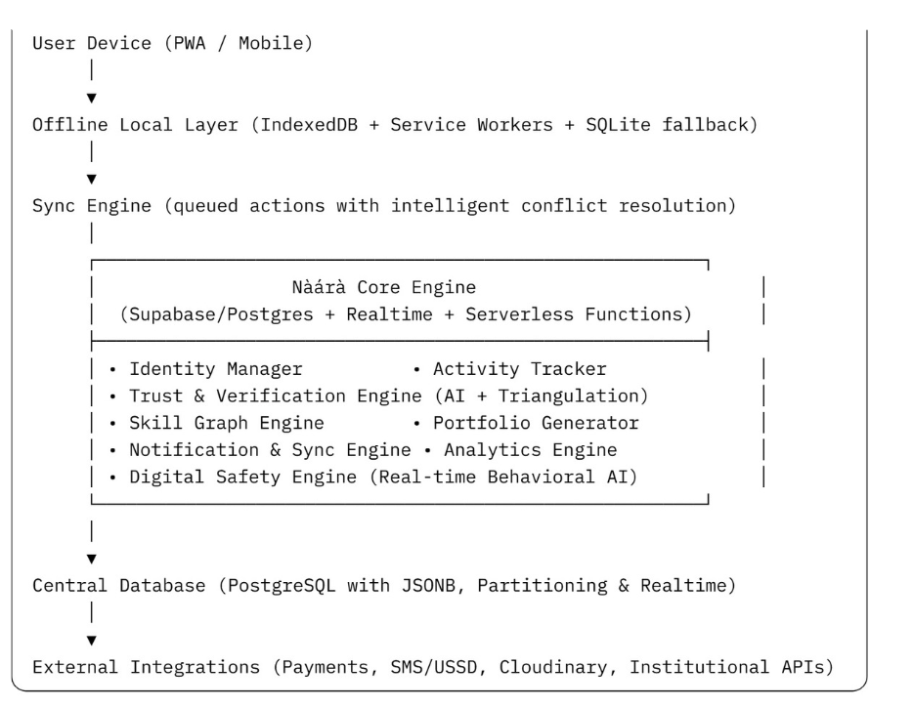
3.1 High-Level System Architecture
The architecture supports horizontal scaling, real-time updates, and graceful degradation in low-connectivity or rural Nigerian environments.
3.2 Core Engine Components
1. Identity Manager Provides a single, secure Nàárà Account for the entire ecosystem. Supports SSO, QR-code identity linking, biometric login, multi-language options, and USSD/SMS fallback. Includes granular consent management to ensure user privacy and compliance.
2. Activity Tracker Logs every user action across all modules as an immutable, timestamped, geolocated record. This serves as the single source of truth for verification, trust scoring, safety analysis, fraud detection, and institutional reporting.
3. Trust & Verification Engine Computes dynamic Trust Scores using a novel triangulated algorithm:

TrustScore(u) = 0.4 \times VerifiedSkillsScore + 0.3 \times EvidenceQualityScore + 0.2 \times PeerCustomerRating + 0.1 \times ConsistencyScore – SafetyPenalty

SafetyPenalty is dynamically applied by the Digital Safety Engine based on flagged messages, reports, or behavioral anomalies. The engine also performs anomaly detection (e.g., mass verifications, location mismatches, unusual messaging patterns).
4. Skill Graph Engine Maintains a directed acyclic graph (DAG) of trade-specific skill trees with prerequisites, levels, and dependencies. Supports community-driven evolution and intelligent recommendations for learning and gig matching. Fully cacheable for offline use.
5. Portfolio Generator Automatically creates verifiable PDF or digital portfolios (with embedded QR codes) from verified skills and activity logs. Supports institutional export formats.
6. Notification & Sync Engine Manages push notifications, SMS/USSD fallbacks, and background synchronization. Uses timestamp + authority-based conflict resolution (master verification takes precedence).
7. Analytics Engine Aggregates anonymized data into real-time dashboards, heatmaps, predictive models, and exportable reports for governments, NGOs, and policymakers.
8. Digital Safety Engine Real-time AI layer that scans messages for phishing and manipulation patterns, applies safety penalties to Trust Scores, processes community reports, and delivers gamified cyber-awareness micro-lessons that actively improve user trust scores.

3.3 Core Data Flow (Example)
An apprentice uploads skill evidence → Activity Tracker logs it → Master verifies → Trust Engine updates score and Skill Graph → Portfolio is generated → Opportunity Infrastructure matches gigs → All actions feed Analytics and Safety Engine.
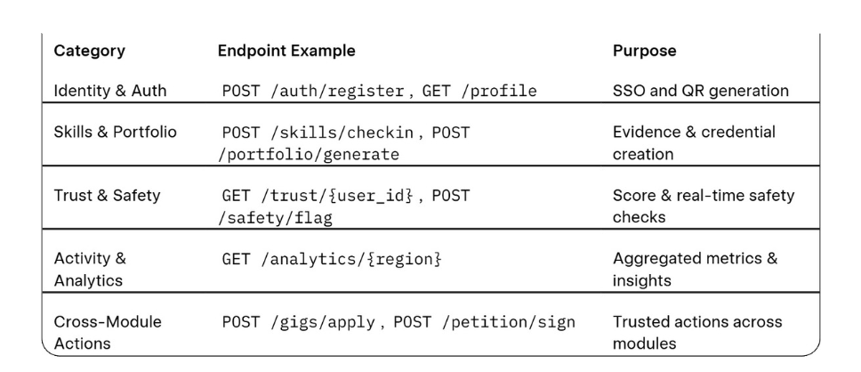
3.4 API Architecture (Key Endpoints)
All APIs enforce JWT authentication, role-based access control, rate limiting, and consent checks.

4.1 Database Design Principles
The database is built on PostgreSQL (via Supabase for realtime capabilities) with heavy use of JSONB fields for flexibility. Every table includes created_at, updated_at, is_synced, and last_synced fields to support offline-first synchronization. Principles include: single source of truth, modular tables with foreign keys, multi-source verification fields, audit trails, and scalability through partitioning.

4.2 Core Tables
users (Identity Table)
- user_id (UUID, PK)
- full_name, username, phone_number (required), email
- role (ENUM: apprentice, master, freelancer, employer, admin)
- trust_score (FLOAT)
- profile_photo, language, is_verified, consent_flags (JSONB)

activity_logs (Single Source of Truth)
- activity_id (UUID, PK), user_id (FK), module_id, action_type, action_details (JSONB), geo_location, timestamp, is_synced

4.3 Module-Specific Tables (Key Examples)
- SkillForge & ProofPortfolio: trades, skills, apprentice_skills (with proof_url, verified_by), portfolios (with skill_summary JSONB).
- Forum: threads, posts, comments, messages (with media JSONB).
- MicroSkill Labs: courses (with media_urls JSONB, offline_pack).
- Opportunity & GlobalGig: gigs (with required_skill_ids JSONB), applications, earnings.
- PetitionHub: petitions (with signatures JSONB, signature_count).
- FreeCycle, PricePulse, etc.: Dedicated tables (e.g., freecycle_items, price_entries, scam_reports with risk_score).
- Trust & Safety: trust_scores (with safety_penalty and breakdown JSONB), safety_reports.

4.4 Cross-Module Interconnections & Offline Considerations
Every table links via user_id. TrustLayer and Digital Safety Engine update scores on every relevant action. Offline support is built-in through is_synced flags, local IndexedDB caching, and conflict resolution prioritizing master verification and timestamps. Media is stored separately with URLs and hashes.
Permissions & Roles are strictly enforced (e.g., Masters verify skills; Admins manage moderation and analytics).
This integrated Core Engine and Database Schema ensures data integrity, trust propagation, real-time safety, and scalability while remaining fully compatible with offline-first deployment in Nigerian contexts.

Part 5 – UX/UI Flows & Demo Script
Design Principles: Mobile-first, clean minimal interface, fast interactions, low data usage, accessibility, and offline indicators.
Core Navigation: Bottom tabs (Home / Skills / Learn / Opportunities / Community / Resources / Profile).
Key User Flows:
- Onboarding: Splash → Sign-up (phone/OTP) → Role selection → Profile setup → Consent.
- SkillForge: Trade cards → Visual skill tree (colored nodes) → Evidence upload → Verification request.
- Portfolio: Auto-generated with QR and trust score display.
- Forum: Trending threads, multimedia posts, private messaging.
- PetitionHub: Create petition → Real-time signature counter and heatmap.
- FreeCycle: Item posting with photo/location → Nearby claims and notifications.
- Digital Safety: Inline warnings on suspicious messages; micro-lesson access.
Demo Script:
- Onboard new apprentice (Chidi, mechanic).
- SkillForge: Upload evidence → Master verifies → Trust score and portfolio update.
- MicroSkill Labs: Download offline course → Completion triggers skill recommendation.
- Opportunity Infrastructure: Apply for verified gig → Earnings tracker.
- PetitionHub + Forum: Create petition/thread with live updates.
- FreeCycle + PricePulse: Post/claim item and submit price entry.
- Digital Safety Engine: Simulate flagged message → Warning and trust adjustment.
- Analytics Dashboard: Show regional impact metrics.

Closing Statement: “FEMZYK NAARA transforms Nigeria’s invisible skill economy into verified, trusted, economically productive infrastructure — connecting skills, opportunity, community, and safety in one ecosystem.”
Part 6 – Technical Stack, Security, Offline-First & Scalability
Desired Stack for the project:
- Frontend: Next.js PWA (offline-first, responsive).
- Backend: Supabase (PostgreSQL + Realtime) or Firebase alternative.
- Storage: Supabase Storage / Cloudinary for media optimization.
- Offline: IndexedDB + Service Workers + background sync.
- Auth: Supabase Auth + JWT + role-based ACL.
- Notifications: Firebase + Africa’s Talking (SMS/USSD).
- Payments: Flutterwave/Paystack (local), Stripe/Payoneer (global).
- Analytics: Supabase Views + Metabase.
Security: TLS, AES-256 encryption, rate limiting, anomaly detection, consent enforcement, full audit logs. Offline-First: All core actions (skill check-ins, petitions, price submissions, etc.) function offline with queued sync. Scalability: Horizontal replicas, regional partitioning, serverless functions, CDN — designed for millions of users.
Monetization Strategy: Freemium model, institutional API licensing (banks/NGOs/government for verification and analytics), certification partnerships, and aggregated insights licensing.
Long-Term Expansion: Nigeria pilot → West Africa → Pan-African rollout with multi-language and multi-currency support.
Part 7 – Professional Notes for AI Developers & MVP Roadmap
Step-by-Step Build Sequence (8-Week MVP):
- Core Engine + Identity + TrustLayer (Weeks 1–2).
- SkillForge + ProofPortfolio + Forum (Weeks 3–4).
- MicroSkill Labs + Digital Safety Engine (Week 5).
- Opportunity Infrastructure + FreeCycle + PetitionHub (Weeks 6–7).
- Analytics + Polish + Offline Sync (Week 8).

AI Integration Guidelines: Auto-skill recommendations, anomaly detection in messages/behavior, dynamic trust recalculation, and generation of cyber-awareness lessons.
MVP Priority: Demonstrate end-to-end value — skill verification, resource sharing, civic engagement, and safety intelligence — using pre-populated demo data.
Post-MVP Roadmap: Add more trades, advanced AI, government integrations, and gamification.

Conclusion & Alignment with The Nigeria Prize for Science
FEMZYK NAARA PLATFORM represents a genuine scientific and technological breakthrough in AI-driven trust systems, offline distributed architectures, graph-based skill modeling, and integrated digital safety for low-resource environments. It directly supports Nigeria’s priorities in youth employment, skills development, financial inclusion, civic participation, and evidence-based governance.

The platform is not merely an application — it is a digital public infrastructure for Nigeria’s informal economy, ready for immediate MVP development and national-scale impact.

Thank You — Building trust. Unlocking opportunity. Empowering communities.

